Data Source Environment Variables in Power Platform

Data Source Environment Variables in Power Platform Solutions - SharePoint by Reza Dorrani
#PowerApps #PowerAutomate #Solutions

Microsoft Documentation:
Environment variables overview

Table of Contents:
00:00 - Introduction
00:45 - Create solution and add components (Power Apps, flows)
04:33 - Create a Power App in solution
04:50 - Enable Canvas App to store environment variables when connecting to SharePoint as data source
08:06 - Create Power Automate flow in solution
08:33 - Use data source variables in Power Automate flows
11:54 - Export a solution from development environment
15:57 - Import a solution into production environment
17:08 - Set environment variables when importing solution
19:40 - Subscribe to Reza Dorrani channel

00:00 – Introduction
00:00 - Introduction

00:45 - Create solution and add components (Power Apps, Cloud flows)
00:45 - Create solution and add components (Power Apps, flows)

04:33 - Create a Power App in solution
04:33 - Create a Power App in solution

04:50 - Enable Canvas App to store environment variables
04:50 - Enable Canvas App to store environment variables when connecting to SharePoint as data source

Enable Automatically create environment variables when adding data sources
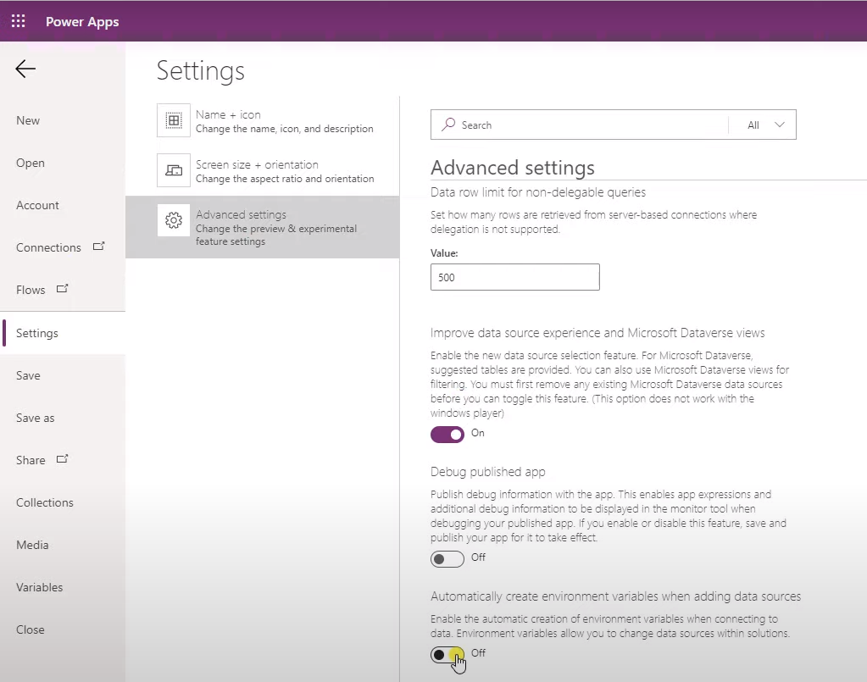

Search for SharePoint connector
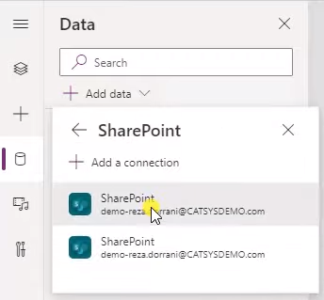

Connect to SharePoint site
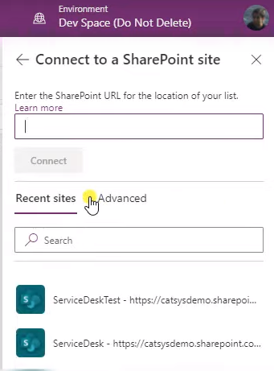

Or select Environment variables, previously created for data source SharePoint
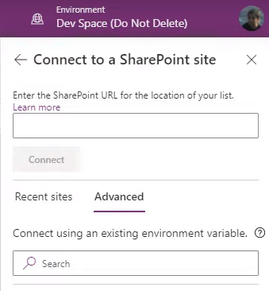

After selecting SharePoint site, select from Lists or Libraries and Connect
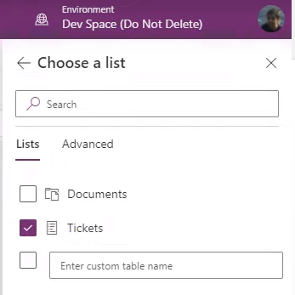

auto creates 2 new Data Source Environment Variables - one for the SharePoint site and one for the SharePoint list
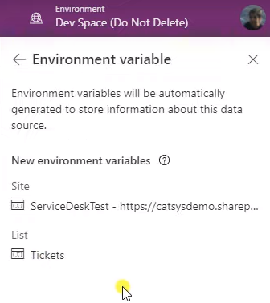

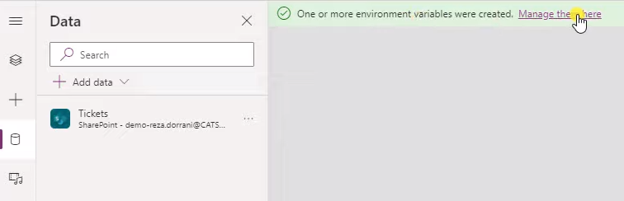

Click on Manage them here will redirect to previously created Solutions in Power Apps Maker Portal
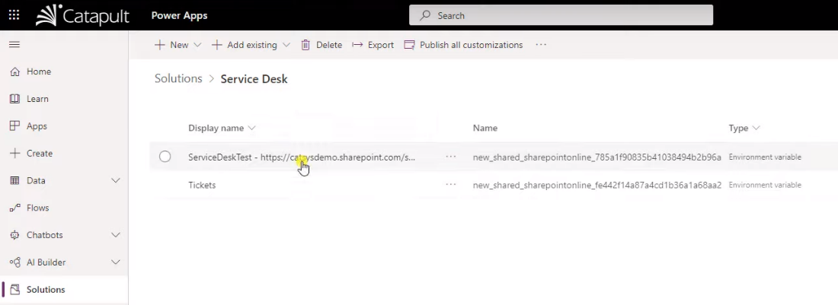

08:06 - Create Power Automate flow in solution
08:06 - Create Power Automate flow in solution

After creation of the Power App, add a new Cloud flow to trigger on newly added list items to the Solution with flow trigger "When a new item is created"
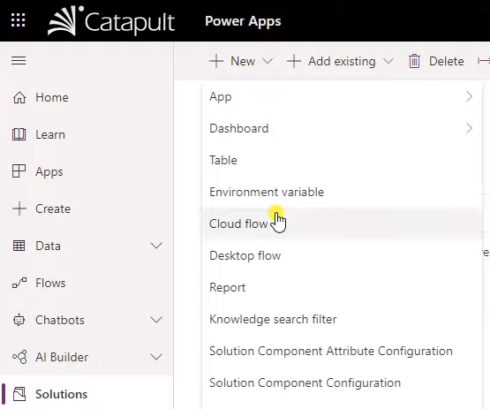

08:33 - Use data source variables in Power Automate
08:33 - Use data source variables in Power Automate flows

Instead of choosing Site and List from dropdown, select Add a custom item
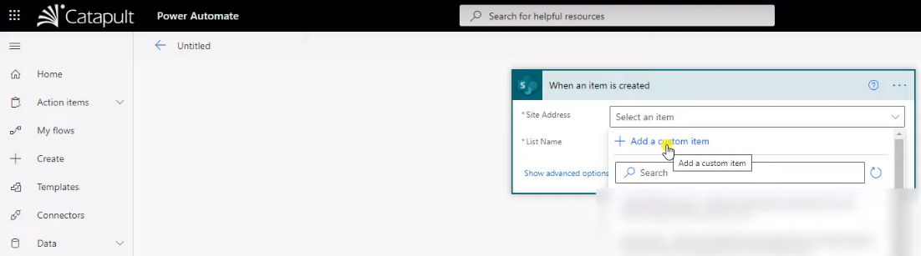

In Dynamic content section
Select previously created Data Source Environment Variable from the Parameters (renamed to Environment Variables any tiume soon) dropdown menu
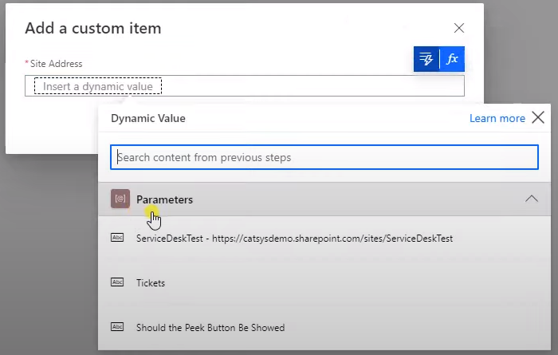

Confirm with OK
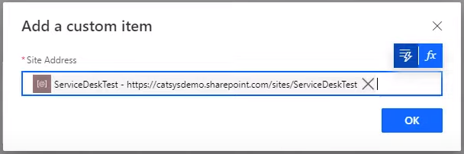

Repeat for SharePoint list selection
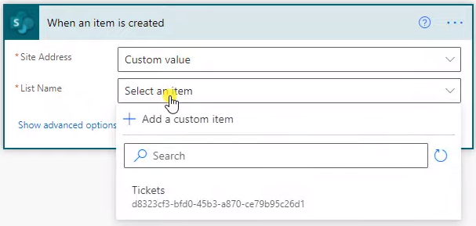

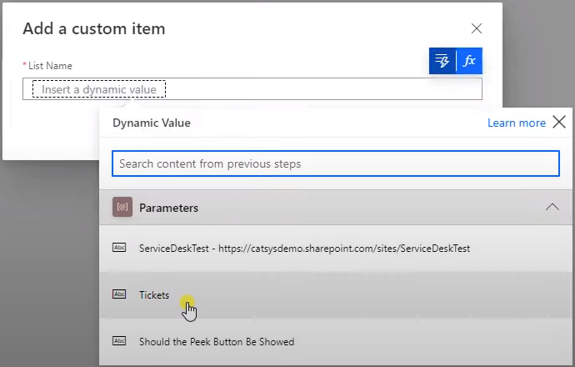

Now you can choose columns from the List via Dynamic Content section
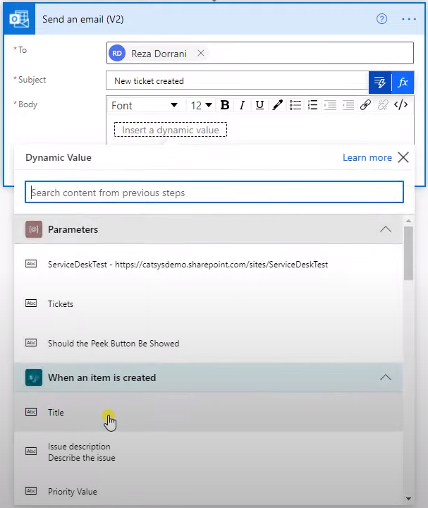

Furthermore, you can also simply add the Data Source Environment Variables
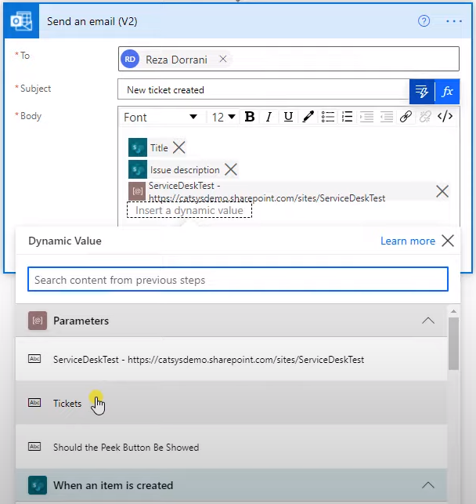

Upon Save, the Cloud flow will become part of the solution
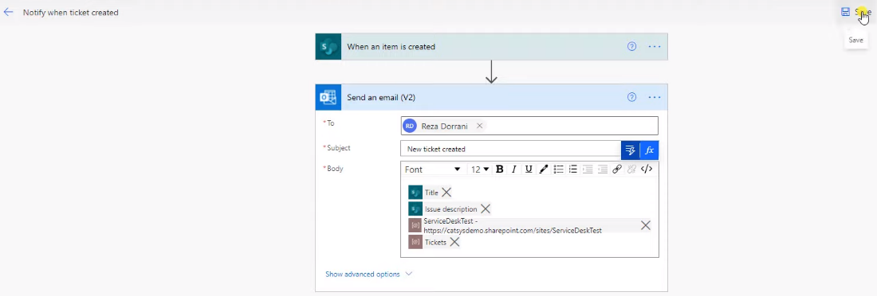

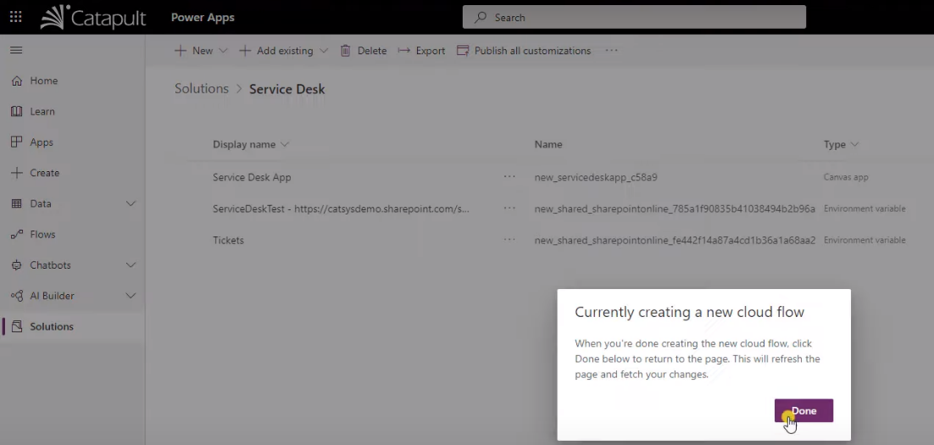

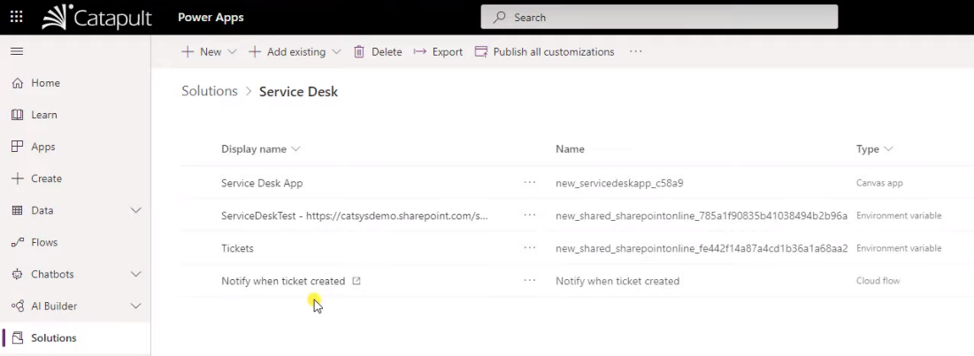

In the Apps section, Play the app and create a new list item
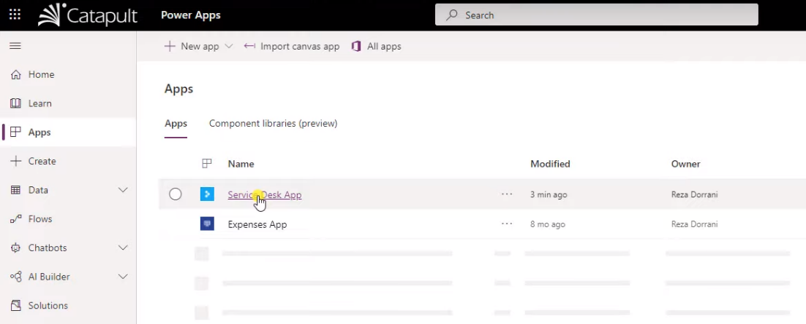

Cloud flow triggers on newly created list item and sends mail notification with list values and the two Data Source Environment Variables
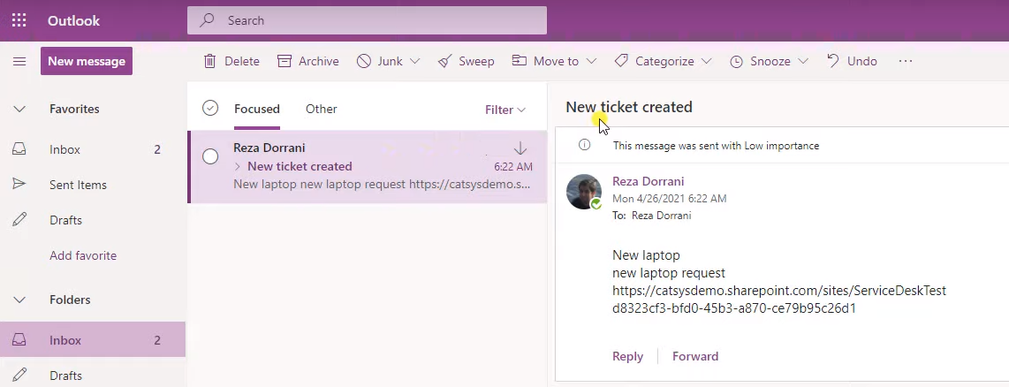

You can add new and also add and import pre-existing components that are not part of the Solution
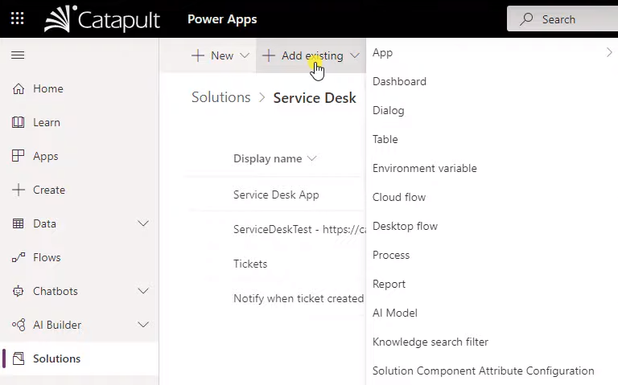

11:54 - Export a solution from development environment
11:54 - Export a solution from development environment

Add component requirement dependency via the Power App's ellipsis menu > + Add required components
→ ensures that any required components, currently not part of the Solution, will be added automatically as well

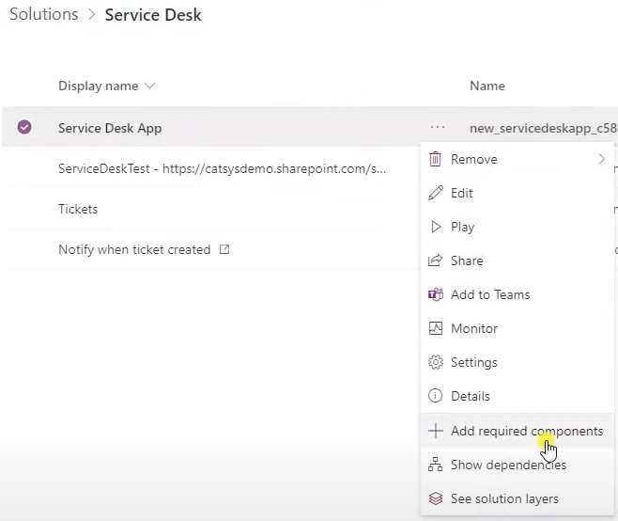

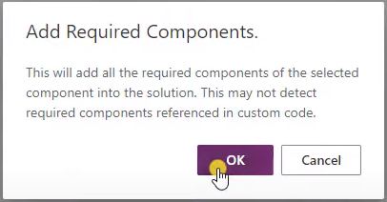

Repeat same procedure for Cloud flow ellipsis menu > + Add required components
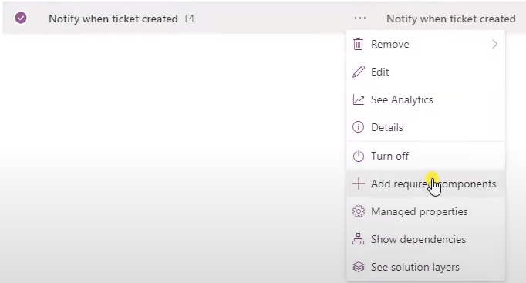

Automatically adds the Cloud flow's connections as Connection Reference components to the Solution
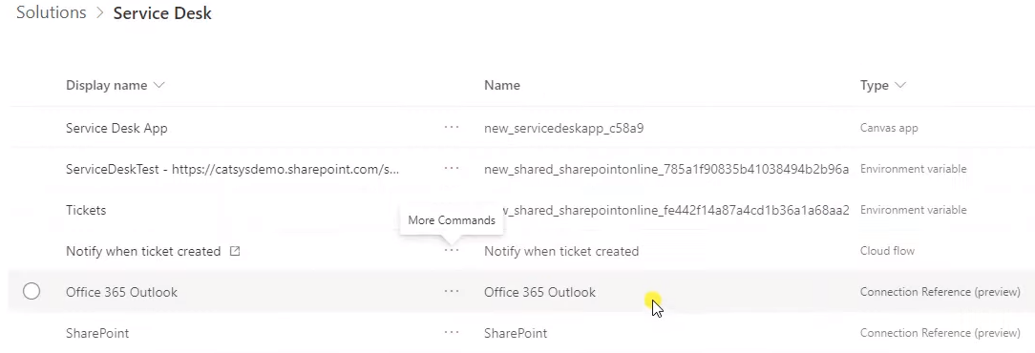

Before exporting the Solution to another environment, remove currently set value for the SharePoint site URL and SharePoint list GUID
Therefore, from the Data Source Environment Variable's ellipsis menu, choose Edit
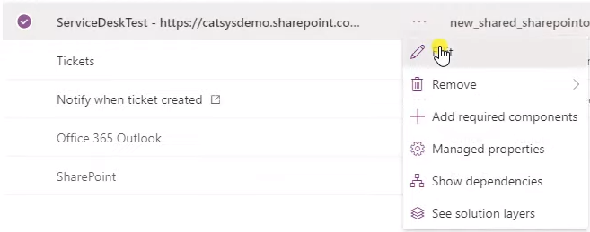

In the Current (site) value's ellipsis menu …
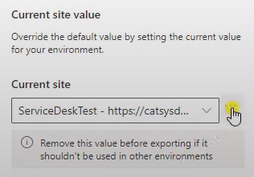
… choose Remove from this solution
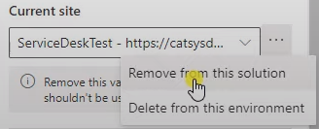

Current value was removed from the solution but can be added back in
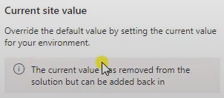

DO NOT choose Delete from this environment (otherwise data source link to Test site is lost)
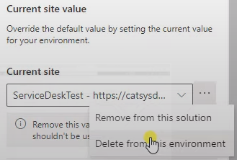

Repeat same steps for SharePoint list Data Source Environment Variable
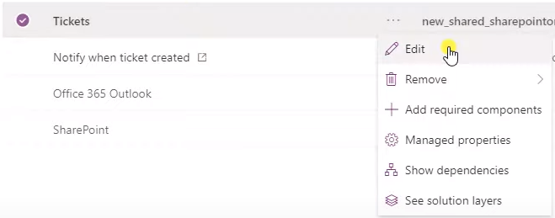

Keep the Site connection untouched and only remove the current list value
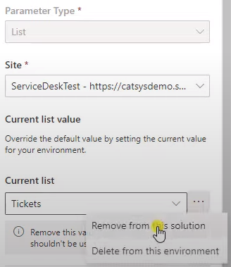

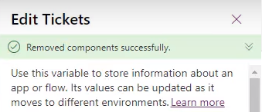

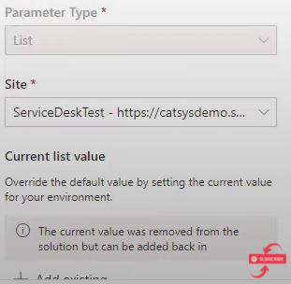

Upon completion, Export solution
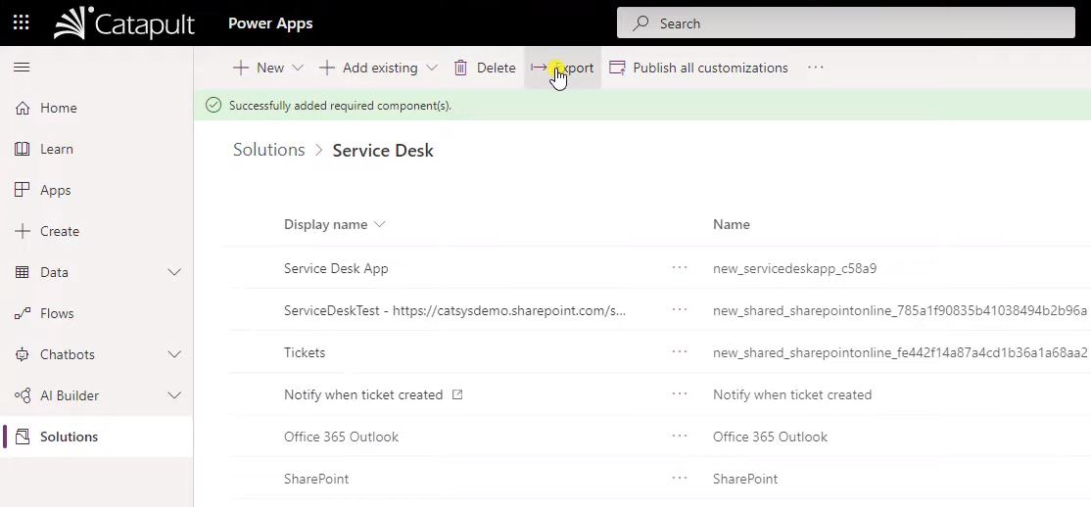

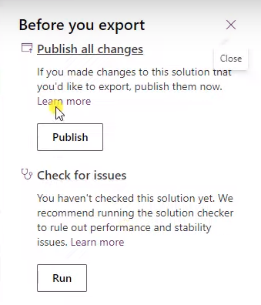
First Publish all changes to ensure all changes are published to Solution prior to Export
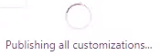

Upon Publishing completed, press Run to Check for issues and press Next
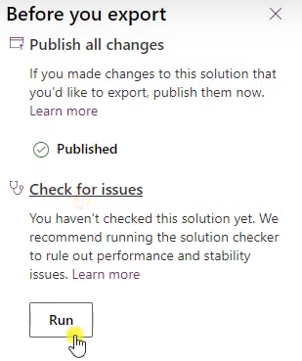

Export solution with provided version number either as
Managed solution (recommended for production and test environments)
i.e.: no changes can be made to components of the solution unless specified and configured in those components' settings
or
Unmanaged solution (move to another development environment)
i.e.: user can make any changes to components of the solution
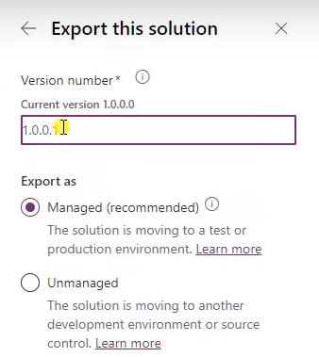
Click Export

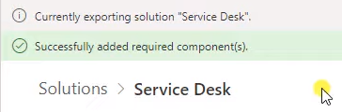

Upon completion of the export, solution zip file will be available in your device's Downloads folder

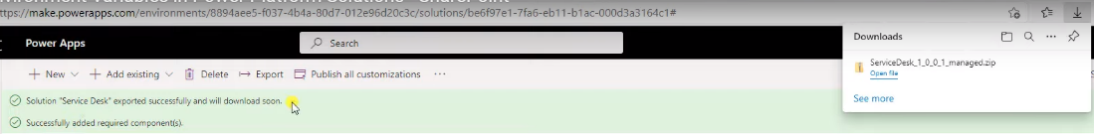

15:57 - Import a solution into production environment
15:57 - Import a solution into production environment

Switch to Production environment
Press Import in Solutions menu
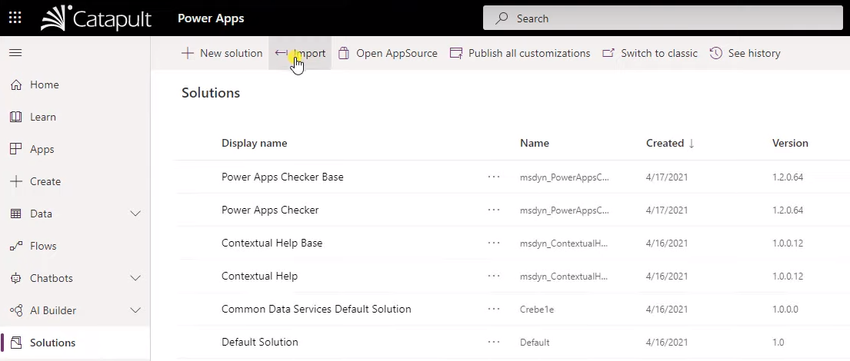

Browse previously exported solution zip file
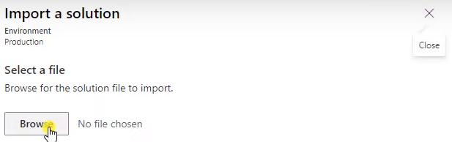

Press Next to import solution file
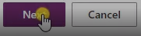

See details of the imported solution
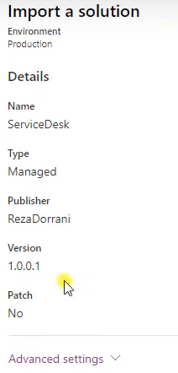

Resume Next
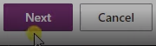

Define the appropriate Connection references
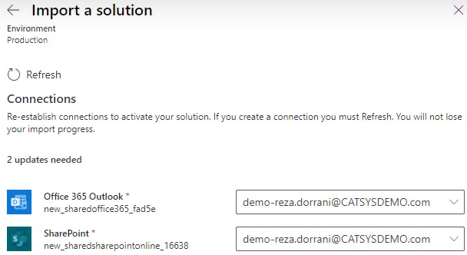

Resume Next
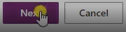

17:08 - Set environment variables when importing solution
17:08 - Set environment variables when importing solution

Define the appropriate Data Source Environment Variables
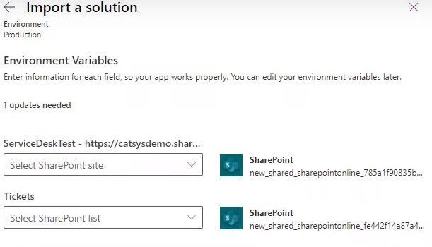
Select desired Production SharePoint site
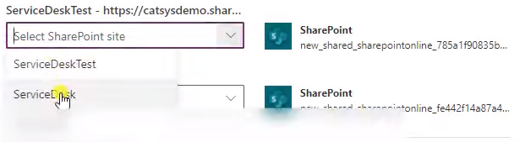

Finally, press Import
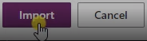
This triggers the import of the managed solution into production environment
Values set in Data Source Environment Variables will automatically be applied to (= replaced in) all Apps and Cloud flows, when utilizing them
no need to change - simply ready to go to use Apps and Cloud flows ☺
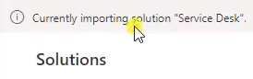

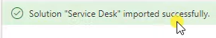

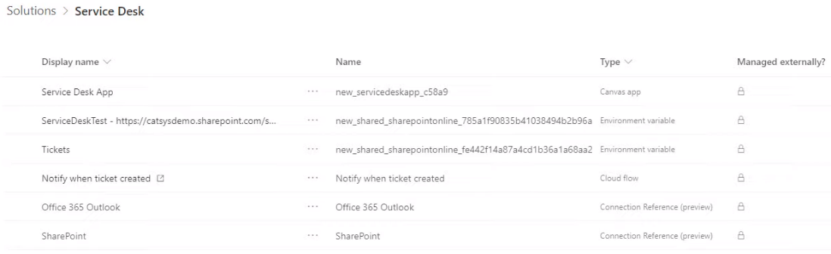
18:10 - Data Source Environment Variable for SharePoint site of imported solution in Production environment is still the Test SharePoint site
The Data Source Environment Variables seem to be updated upon first utilization of the Apps and Cloud flows (after consent to the required permissions of the Connector References, right?
see Values set in Data Source Environment Variables will automatically be applied to (= replaced in) all Apps and Cloud flows when utilizing them
19:25 - even after utilizing the Power App / Cloud flow in the production environment, the SharePoint site name is not updated

[…] A moment in the video, that especially grasped my attention was at 18:10 where I noticed that the Data Source Environment Variable for SharePoint site of the imported solution in Production environment is still stating the Test SharePoint site name - ServiceDeskTest - and probably also site URL. Earlier in the video, you mentioned that the values set in the Data Source Environment Variables are applied to (= updated/replaced in) all Apps and Cloud flows when utilizing them. After allowing / consenting the required permissions of the Connector References, you played/run the App. However, at 19:25, i.e. after utilizing the Power App / Cloud flow in the production environment's solution, the Data Source Environment Variable Display name and Name (containing GUID) is still not updated, e.g. "ServiceDeskTest". Minor issue. Lessons learned: Name the the SharePoint lists / libraries identical. For the SharePoint site Display name, I prefer different names like in your demo to better distinguish the different environments. However, I would prefer if the Display name of the Data Source Environment Variable would update upon utilization of the Apps/Cloud flows. At first sight, this caused me some confusion and needed some time to recap and let your previous explanations sink in. ;)

Aus <https://www.youtube.com/watch?v=BFGcXSAgawM>

Play / Run App
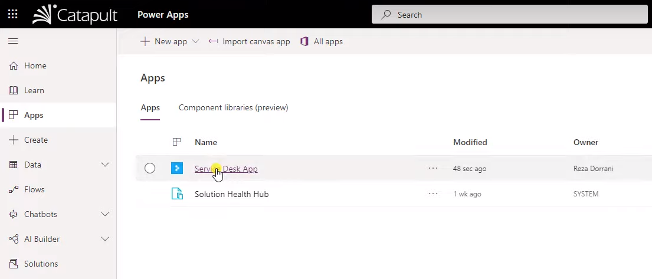

Allow / consent SharePoint connector permissions in order to update the solution's Connector Reference components
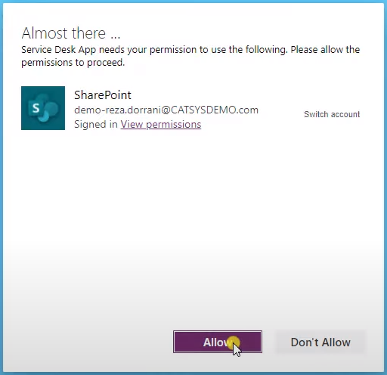

App is now pointing to the Production SharePoint site and (empty) SharePoint list

Add new list item
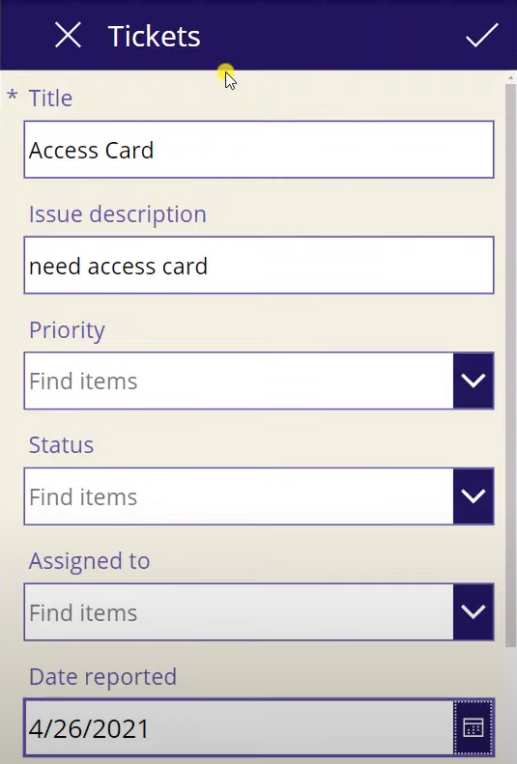

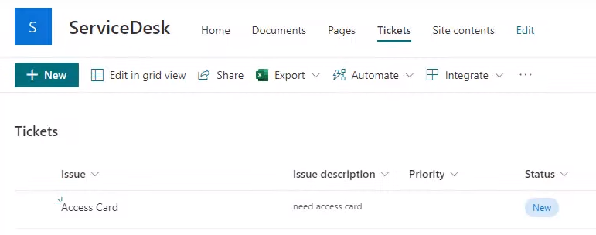
And also the Production Cloud flow triggers with the appropriate Data Source Environment Variables
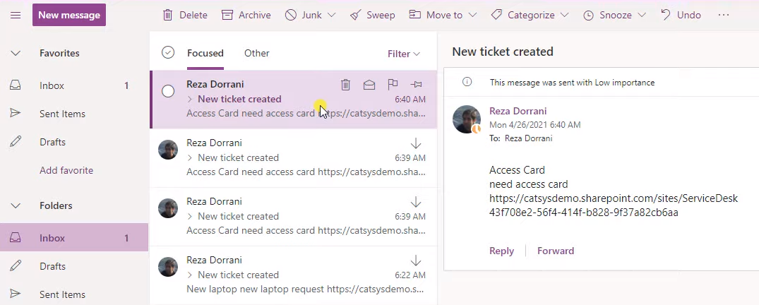

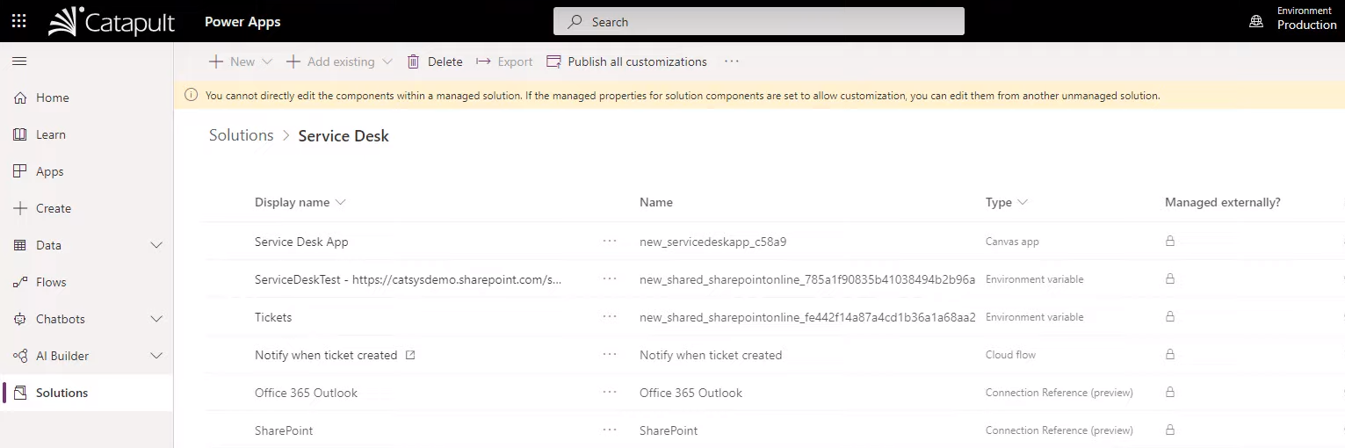

Major improvement of ALM (= Application Lifecycle Management) capabilities of solutions working with SharePoint Online as a data source

